Effect of Number of Stages in a Tesla Valve Performance
(Times new roman, 16 pts, Plain text)
Erol KURT
Institution, City, Country, Email address, ORCID: xxxx-xxxx-xxxx-xxxx (ORCID No. must be given for each authors)

Özgür EROL
Institution, City, Country, Email address, ORCID: xxxx-xxxx-xxxx-xxxx (ORCID No. must be given for each authors)

Cite this paper as: | Kurt, E., Erol, O., Effect of Number of Stages in a Tesla Valve Performance. 6. Int. Conf. Mech. Engr. 8-9 July 2026, London, UK (Write here your present paper here.)

Abstract: | The abstract should be prepared via Times New Roman (Font) and 10 pts, single spaced with 2 cm margins on all sides and align full. The length of Abstract should be between 150 and 200 words. The abstract should be informative by referring study aims, the methodology, the instruments, the major findings and the implications of the study.
Keywords: | 3-5 keywords should be given

© 2026 Published by ICMECE

Nomenclature | (if needed, otherwise delete this Nomenclature table)
Abreviation1  Abreviation2  Abreviation3 | Description1  Description2  Description3

1. INTRODUCTION

In taking a step toward expediting the publication process, ICMECE conference uses a web-based submission and peer-review. If you have not already create an account, create an account (register) for yourself in the system at the left side of the page: https://cmt3.research.microsoft.com/ICMECE2026
To monitor the progress of your manuscript throughout the review process, just login our system periodically and check your status of paper.

The Introduction should contain the literature description on the studied matter. When preparing your manuscript, please use and follow our template.

Prepare your manuscript and illustrations in appropriate format, according to the instructions given below. Please also be sure that your paper conforms to the scientific and style instructions of the Conference, given below here.
Each article should include an informative, comprehensive abstract of 150 to 200 words with 10 pts. The abstract should explain the critical information related to the paper's aim, methodology, findings, results, and conclusions. Three - five key words should also be given after the abstract.
General Rules
The manuscript should be prepared by MS Word (6.0 or latest versions), in an A4 (21 x 29,7 cm.) paper size. The margins should be 2 cm from left and right and 2,5 cm from top and bottom. The text should be written in Times New Roman (Font) and 11 pts (excludes, Title and abstract). Paragraphs should be single spaced with justified alignment. Between the paragraphs there should be a single space.

The Tables and the References should be prepared by using Times New Roman (10 pts). There should be single space after headings. The authors should not use any page numbers in their manuscripts. Appendices should be placed at the end of the manuscript, after the reference and bibliography lists.

2. SECTIONS

Section titles can be Introduction, Theory, Experimental Setup, Methodology, Model, Simulation, Results and Discussions, Experimental Findings, Analytical Study, etc. But other titles are also welcome. Uppercase letters should be used in all section headings.

Figures, Tables and Equations: Figures, Tables and Equations should be given in the same page (not separate pages). If any of them is longer than one page, it should be given in the Appendix.

You can see some equation examples below:

$${ P}_{t}=0.5C_{p}\left(λ\right)ρSV^{3}$$ | (1)

$$C_{p}=\left[0.73\left(\frac{151}{λ^{'}}\right)-0.002β-13.2\right]exp\left(\frac{-18.4}{λ^{'}}\right)$$ | (2)

$$\left[\begin{matrix}φ_{s1} \\ φ_{s2} \\ φ_{r}\end{matrix}\right]=\left[\begin{matrix}\left[L_{s1,s1}\right] & \left[L_{s1,s2}\right] & \left[L_{s1,r}\right] \\ \left[L_{s2,s1}\right] & \left[L_{s2,s2}\right] & \left[L_{s2,r}\right] \\ \left[L_{r,s1}\right] & \left[L_{r,s2}\right] & \left[L_{r,r}\right]\end{matrix}\right]\left[\begin{matrix}i_{s1} \\ i_{s1} \\ i_{r}\end{matrix}\right]$$ | (3)

$$F=ma$$ | (4)

After each equations put one blank line. Do not use (x) or (.) for ordinary mathematical product. Just leave a blank for multiplication. Put reference to equations as Eq. (1) or multiple references as Eqs. (1-4) or Eqs. (1,2).

Number all figures with Arabic numerals sequentially. The resolution should be sufficient to read in English. The figure names should be given below the Figure and the caption beginning with “Figure” should be written in italic.

The figure captions should contain short but sufficient info with all parameters (see in Figure 1). Photos can also be accepted. The figure caption should be at the same page with the figure itself.

In the manuscript, the figures should be referenced as “Figure X”, where X is the number of the figure (e.g. “As it is given in Figure 5, …”).

An example for the figures is given in the Figure1 below:

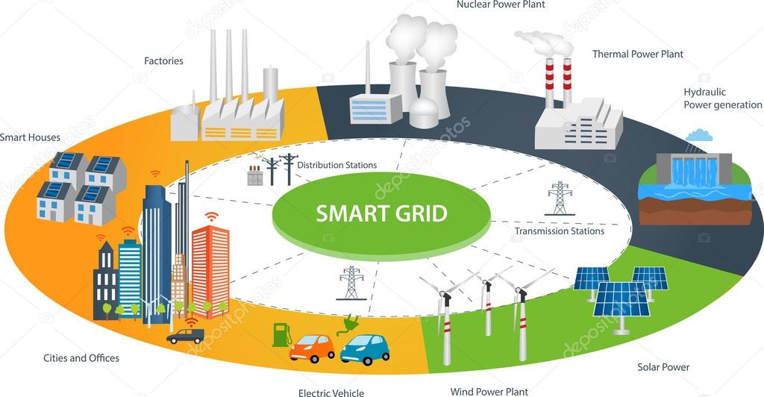

(a)

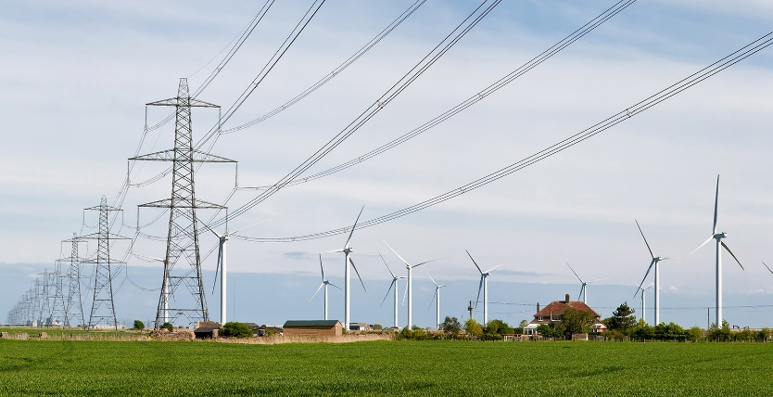
(b)
Figure 1. (a) Italic (b) seperated.

Number all tables with Arabic numerals sequentially. The table names should be placed above the table. There should be the word “Table” and the brief explanation of title should be found and italicized.

Table X. The name of table--------- (Italic)
Item no | Item Description | Percentage
1 | Item 1 | N | N | N | N | N
2 | Item 2 | N | N | N | N | N
3 | Item 3 | N | N | N | N | N

The table caption should be at the same page with the table itself.

In the manuscript, the figures should be referenced as “Table X”, where X is the number of the table (e.g. “As it is given in Table 5, …”).

Sub-headings and Methology:

Sub-headings should not be numbered and all the first letters should be capitalized.

For sub-sub sections:
Sub-sub headings should not be numbered and only the first letter of the heading should be capital letter.

ACKNOWLEDGMENT
You can add an acknowledgment and thank to institutions or real people. You can also write here your project number and code.

REFERENCES

DO NOT USE INTERNET SOURCES IF YOU HAVE BOOK, CONFERENCE OR JOURNAL REFERENCES.
(For Journal articles)
[Reference number] Author, AA, Author, BB, Author, CC.. Title of article. Title of Periodical Year, volume number, pages. DOI: http://dx.doi.org/xx.xxx/yyyyy

[1] Naciri, M , Aggour, M , Ait Ahmed, W . Wind energy storage by pumped hydro station. Journal of Energy Systems 2017; 1: 32-42 <http://dergipark.gov.tr/jes/issue/30882/329315>

(For books)
[Reference number] Author, AA. Title of work: Capital letter also for subtitle. Location: Publisher, Year.

[2] Kurt E, Kasap R. The Science of Complexity Chaos. Ankara, TURKEY: Nobel Publishing House, 2011.

(Chapter in a book)
[Reference number] Author, AA, Author, BB. Title of chapter. In AA Editor, BB Editor (Eds.), Title of book, Location: Publisher, Year, pp-pp.

[3] Kurt E, Uzun Y. Nonlinear Problems in Piezoelectric Harvesters under Magnetic Field. In: Bizon N, Tabatabaei NM, Blaabjerg F, Kurt E, editors. Energy Harvesting and Energy Efficiency Technology, Methods, and Applications. Cham, Switzerland: Springer International Publishing, 2017. pp. 107-142.

(For Thesis/Dissertation)
[Reference number] Surname, FN. Title of dissertation (MSc or PhD). Name of Institution, Location, Country, Year

[4] Kurt E. Pattern Formation in Rotating Fluid Systems under the Influence of Magnetic Fields. PhD, University of Bayreuth, Bayreuth, Germany, 2004.

(Conference Papers)
[Reference number] Author, AA. Title of contribution. In: Proceedings of the Conference Name, Dates, Publisher, Location: pp. xxx-xxx,

[5] Bizon N, Kurt E, Iana G. Airflow real-time optimization strategy for fuel cell hybrid power sources with fuel flow based on load following. In: ECRES 2017 5. European Conference on Renewable Energy Systems; 27-30 August 2017: Vizyon Publishing House, pp. 222-230.

(One Paragraph Bibliograph for all authors.)
Erol KURT took his M. Sc. degree from the Inst. Science & Technology, Gazi University in Ankara, Turkey in 2001. He was awarded by an European Graduate College Grant during his Ph. D study at the Inst. Physics & Math., Bayreuth University in Germany. He completed his Ph. D. degree in 2004 on the instabilities of rotating magnetic fluids and worked at Turkish Atomic Energy Authority R&D Department for 3 years. He was assigned to the position of Assoc. Prof. at Technology Faculty, Gazi University. His main research areas include nonlinear phenomena in electrical/electronic circuits, electric machine design, mechanical vibrations, chaos, plasmas and magneto hydrodynamics. He is chairman to European Conference on Renewable Energy Systems (ECRES) and the guest editor for some reputable journals. He is the Editor-in-Chief to Journal of Energy Systems (dergipark.gov.tr/jes) and the member of Turkish Science Research Foundation (TUBAV).

Özgür EROL gained his M. Sc. degree from Middle East Technical University in Ankara, Turkey in 2002. After working in different companies he completed his Ph. D. degree in 2012. He has been working in Başkent University since 2007.

Appendix (if any)

