A Spherical Symmetrical Potential with Pauli’s Spin Factor on He
(Times new roman, 16 pts, Plain text)
Erol KURT
Institution, City, Country, Email address, ORCID: xxxx-xxxx-xxxx-xxxx (ORCID No. must be given for each authors)

Kahtalı YAZAR
Institution, City, Country, Email address, ORCID: xxxx-xxxx-xxxx-xxxx (ORCID No. must be given for each authors)

Richard John BACH
Institution, City, Country, Email address, ORCID: xxxx-xxxx-xxxx-xxxx (ORCID No. must be given for each authors)

Cite this paper as: | Kurt, E., Yazar, K., Bach, R.J., Article title. 10. Eur. Conf. Ren. Energy Sys. 7-9 May 2022, Istanbul, Turkey (Write here your present paper)

Abstract: | The abstract should be prepared via Times New Roman (Font) and 10 pts, single spaced with 2 cm margins on all sides and align full. The length of Abstract should be between 150 and 200 words. The abstract should be informative by referring study aims, the methodology, the instruments, the major findings and the implications of the study.
Keywords: | 3-5 keywords should be given

© 2023 Published by ICMECE

Nomenclature | (if needed, otherwise delete this Nomenclature table)
Abreviation1  Abreviation2  Abreviation3 | Description1  Description2  Description3

1. INTRODUCTION

In taking a step toward expediting the publication process, ECRES conference uses a web-based submission and peer-review. If you have not already create an account, create an account (register) for yourself in the system at the left side of the page: https://cmt3.research.microsoft.com/ECRES2018
To monitor the progress of your manuscript throughout the review process, just login our system periodically and check your status of paper.

The Introduction should contain the literature description on the studied matter. When preparing your manuscript, please use and follow our template. JES employs an anonymous review policy (i.e., masked review). Therefore, the author's (authors’) name(s) and affiliation should not appear on any part of the article.
Prepare your manuscript and illustrations in appropriate format, according to the instructions given below. Please also be sure that your paper conforms to the scientific and style instructions of the Conference, given below here.
Each article should include an informative, comprehensive abstract of 150 to 200 words with 10 pts. The abstract should explain the critical information related to the paper's aim, methodology, findings, results, and conclusions. Three - five key words should also be given after the abstract.

General Rules
The manuscript and Fig. 1 should be typed in using MS Word (6.0 or latest versions), A4 (21x29,7 cm.) paper size, Times New Roman (Font) and 11 pts (excludes, Title and abstract), single spaced with 2 cm margins on all sides and align full.

The Tables and the References should be prepared by using Times New Roman (10 pts). There should be single space after headings. The authors should not use any page numbers in their manuscripts. Appendixes should be placed at the end of the manuscript, after the reference and biblio lists.

2. SECTIONS

Section titles can be Theory, Experimental Setup, Methodology, Model, Simulation, Results and Discussions, Experimental Findings, Analytical Study, etc. But other titles are also welcome. Uppercase letters should be used in all section headings.

2.1. Sub-headings and Methology:
Sub-headings should not be numbered and all the first letters should be capitalized.

2.2. Figures, Tables and Equations: Figures, Tables and Equations should be given in the same page (not separate pages). If any of them is long as a whole page, it should be given into the Appendixes.

2.3. Figures preperation: Number all figures with Arabic numerals sequentially. The resolution should be sufficient two read in English. The figure names should be given below the Figure and the name “figure” should be italicized. An example is presented below:

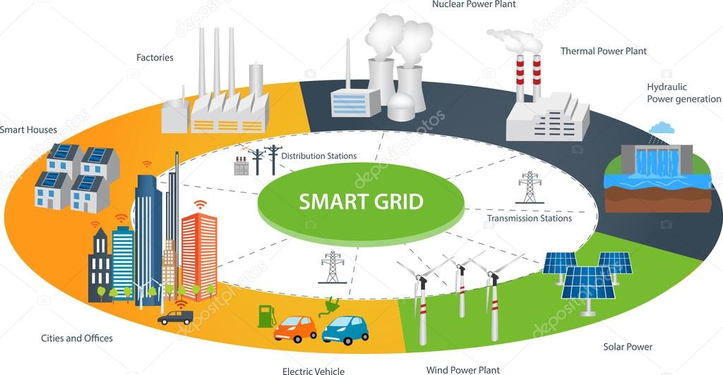

(a)

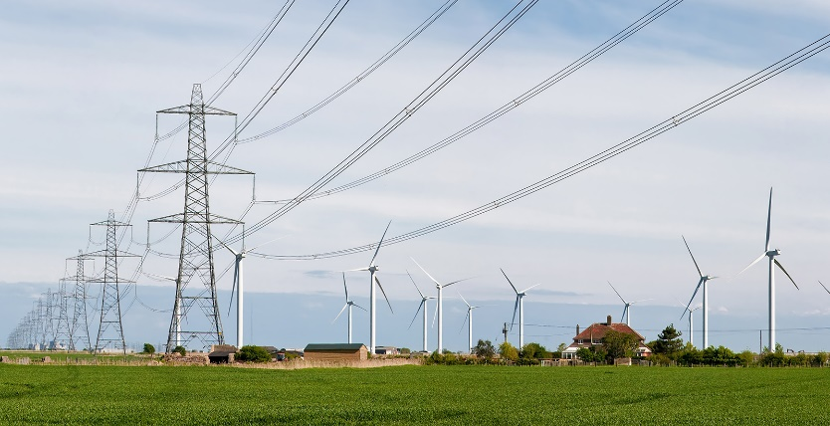
(b)
Figure 1. (a) Italic (b) seperated.

The figure captions should contain short but sufficient info with all parameters (see in Fig. 1). Photos can also be accepted. The figure caption should be at the same page with the figure itself.

2.3.1. For sub-sub sections: Number all tables with Arabic numerals sequentially. The table names should be placed above the table. There should be the word “Table” and the brief explanation of title should be found and italicized.

Table X. The name of table--------- (Italic)
Item no | Item Description | Percentage
1 | Item 1 | N | N | N | N | N
2 | Item 2 | N | N | N | N | N
3 | Item 3 | N | N | N | N | N

The table caption should be at the same page with the figure itself.

2.3.2. For sub-sub sections: See some examples as:

$${ P}_{t}=0.5C_{p}\left(λ\right)ρSV^{3}$$ | (1)

$$C_{p}=\left[0.73\left(\frac{151}{λ^{'}}\right)-0.002β-13.2\right]exp\left(\frac{-18.4}{λ^{'}}\right)$$ | (2)

$$\left[\begin{matrix}φ_{s1} \\ φ_{s2} \\ φ_{r}\end{matrix}\right]=\left[\begin{matrix}\left[L_{s1,s1}\right] & \left[L_{s1,s2}\right] & \left[L_{s1,r}\right] \\ \left[L_{s2,s1}\right] & \left[L_{s2,s2}\right] & \left[L_{s2,r}\right] \\ \left[L_{r,s1}\right] & \left[L_{r,s2}\right] & \left[L_{r,r}\right]\end{matrix}\right]\left[\begin{matrix}i_{s1} \\ i_{s1} \\ i_{r}\end{matrix}\right]$$ | (3)

$$F=ma$$ | (4)

After each equations put one blank line. Do not use (x) or (.) for ordinary mathematical product. Just leave a blank for multiplication. Put reference to equations as Eq. (1) or multiple references as Eqs. (1-4) or Eqs. (1,2).

ACKNOWLEDGMENT
You can add an acknowledgment and thank to institutions or real people. You can also write here your project number and code.

REFERENCES

DO NOT USE INTERNET SOURCES IF YOU HAVE BOOK, CONFERENCE OR JOURNAL REFERENCES.
(For Journal articles)
Author, AA, Author, BB, Author, CC.. Title of article. Title of Periodical Year, volume number, pages. DOI: http://dx.doi.org/xx.xxx/yyyyy

[1] Naciri, M , Aggour, M , Ait Ahmed, W . Wind energy storage by pumped hydro station. Journal of Energy Systems 2017; 1: 32-42 <http://dergipark.gov.tr/jes/issue/30882/329315>

(For books)
Author, AA. Title of work: Capital letter also for subtitle. Location: Publisher, Year.

[2] Kurt E, Kasap R. The Science of Complexity Chaos. Ankara, TURKEY: Nobel Publishing House, 2011.

(Chapter in a book)
Author, AA, Author, BB. Title of chapter. In AA Editor, BB Editor (Eds.), Title of book, Location: Publisher, Year, pp-pp.

[3] Kurt E, Uzun Y. Nonlinear Problems in Piezoelectric Harvesters under Magnetic Field. In: Bizon N, Tabatabaei NM, Blaabjerg F, Kurt E, editors. Energy Harvesting and Energy Efficiency Technology, Methods, and Applications. Cham, Switzerland: Springer International Publishing, 2017. pp. 107-142.

(For Thesis/Dissertation)
Surname, FN. Title of dissertation (MSc or PhD). Name of Institution, Location, Country, Year

[4] Kurt E. Pattern Formation in Rotating Fluid Systems under the Influence of Magnetic Fields. PhD, University of Bayreuth, Bayreuth, Germany, 2004.

(Conference Papers)
Author, AA. Title of contribution. In: Proceedings of the Conference Name, Dates, Publisher, Location: pp. xxx-xxx,

[5] Bizon N, Kurt E, Iana G. Airflow real-time optimization strategy for fuel cell hybrid power sources with fuel flow based on load following. In: ECRES 2017 5. European Conference on Renewable Energy Systems; 27-30 August 2017: Vizyon Publishing House, pp. 222-230.

(One Paragraph Bibliograph for all authors.)

Erol KURT took his M. Sc. degree from the Inst. Science & Technology, Gazi University in Ankara, Turkey in 2001. He was awarded by an European Graduate College Grant during his Ph. D study at the Inst. Physics & Math., Bayreuth University in Germany. He completed his Ph. D. degree in 2004 on the instabilities of rotating magnetic fluids and worked at Turkish Atomic Energy Authority R&D Department for 3 years. He was assigned to the position of Assoc. Prof. at Technology Faculty, Gazi University. His main research areas include nonlinear phenomena in electrical/electronic circuits, electric machine design, mechanical vibrations, chaos, plasmas and magneto hydrodynamics. He is chairman to European Conference on Renewable Energy Systems (ECRES) and the guest editor for some reputable journals. He is the Editor-in-Chief to Journal of Energy Systems (dergipark.gov.tr/jes) and the member of Turkish Science Research Foundation (TUBAV).

Kahtali YAZAR took his M. Sc. degree from the Inst. Science & Technology, Gazi University in Ankara, Turkey in 2001. He was awarded by an European Graduate College Grant during his Ph. D study at the Inst. Physics & Math., Bayreuth University in Germany. He completed his Ph. D. degree in 2004 on the instabilities of rotating magnetic fluids and worked at Turkish Atomic Energy Authority R&D Department for 3 years. He was assigned to the position of Assoc. Prof. at Technology Faculty, Gazi University. His main research areas include nonlinear phenomena in electrical/electronic circuits, electric machine design, mechanical vibrations, chaos, plasmas and magneto hydrodynamics. He is chairman to European Conference on Renewable Energy Systems (ECRES) and the guest editor for some reputable journals. He is the Editor-in-Chief to Journal of Energy Systems (dergipark.gov.tr/jes) and the member of Turkish Science Research Foundation (TUBAV).

Richard John BACH took his M. Sc. degree from the Inst. Science & Technology, Gazi University in Ankara, Turkey in 2001. He was awarded by an European Graduate College Grant during his Ph. D study at the Inst. Physics & Math., Bayreuth University in Germany. He completed his Ph. D. degree in 2004 on the instabilities of rotating magnetic fluids and worked at Turkish Atomic Energy Authority R&D Department for 3 years. He was assigned to the position of Assoc. Prof. at Technology Faculty, Gazi University. His main research areas include nonlinear phenomena in electrical/electronic circuits, electric machine design, mechanical vibrations, chaos, plasmas and magneto hydrodynamics. He is chairman to European Conference on Renewable Energy Systems (ECRES) and the guest editor for some reputable journals. He is the Editor-in-Chief to Journal of Energy Systems (dergipark.gov.tr/jes) and the member of Turkish Science Research Foundation (TUBAV).

Appendixes (if any)

